

**Experiment No. 2**

**Title: Arrays, Image and File handling functions, User Defined function in PHP**

**Batch:A3 Roll No.:16010421073 Experiment No.:2 Aim:** Write PHP script for demonstrating use of arrays, functions, image and file handling functions.

**Resources needed:** Windows OS, Web Browser, Editor, and XAMPP Server

## Pre Lab/ Prior Concepts:

Students should have prior knowledge of HTML/CSS/Basic Programming.

## Theory:

**What is PHP Arrays**

Arrays are complex variables that allow us to store more than one value or a group of values under a single variable name.

## Types of Arrays in PHP



There are three types of arrays that you can create. These are:

1. Indexed array — An array with a numeric key.
2. Associative array — An array where each key has its own specific value.
3. Multidimensional array — An array containing one or more arrays within itself.
4. Indexed Arrays Example

<?php

echo "<br><b> --CREATING & DISPLAYING NUMERIC ARRAY--

</b><br><br>";

$languages = array("PHP", "JAVA", "PYTHON", "C++");

$languages[0]="C"; //will overwrite "PHP"at index 0

$languages[4]="PHP";//will add PHP at index 4 var_dump($languages);

?>

**var_dump()** function dumps information about one or more variables. The information holds type and value of the variable(s).

1. Associative Array Example

<?php

echo "<br><br><b> --CREATING & DISPLAYING ASSOCIATIVE ARRAY-

- </b><br>";

$subjectcode=array(111=>"C",222=>"JAVA",333=>"PYTHON",444=>"C++",5 55=>"PHP");

echo "<br><br><b> ACCESSING ASSOCIATIVE ARRAY USING KEY

</b><br>";

echo "SUBJECT with code 333 is ::".$subjectcode[333];

//echo $subjectcode[777]; //throw php error

echo "<br><br><b> DISPLAYING ASSOCIATIVE ARRAY USING KEY THROUGH LOOPS</b><br>";

foreach ($subjectcode as $code => $subvalue){ echo "SubjectCode $code ::$subvalue <br>";}

echo "<br><b> Displaying raw value of array</b><br>"; print_r($subjectcode);

?>

**print_r()** function prints the information about a variable in a more human-readable way.

1. Multidimensional Array

<?php

echo "<br><b> --CREATING & DISPLAYING MULTIDIMENSIONAL ARRAY --

</b><br>";

$courses = array(

array("code" => "001", "subject" => "PIC","sem" => "First"),

array( "code" => "003","subject" => "PYTHON", "sem" => "Third"),

array( "code" => "004", "subject" => "Advance JAVA/PYTHON", "sem" => "Fourth")

);

echo "<b> Display multidimensional array</b><br>";



$keys = array_keys($courses);

for($i = 0; $i < count($courses); $i++) { echo $keys[$i] . "<br>";

foreach($courses[$keys[$i]] as $key => $value) { echo $key . " : " . $value . "<br>";

} }

?>

**array_keys()** function returns an array containing the keys.

## Functions in PHP

1. PHP Built-in Functions

-A function is a self-contained block of code that performs a specific task.

-PHP has a huge collection of internal or built-in functions that you can call directly within your PHP scripts to perform a specific task, like gettype(), print_r(), var_dump, etc.

1. PHP User-Defined Functions
   1. Syntax for creating Functions function functionName(){

// Code to be executed

}

* 1. function myFunc($oneParameter, $anotherParameter){

// Code to be executed

}

* 1. function myFunc($oneParameter, $anotherParameter=value){

// Code to be executed

}

//calling such functions

$myFunc(“value1”, “value2”); $myFunc(“value1”);// both will work

* 1. function myFunc($oneParameter, $anotherParameter){ return $returnvalue;

}

## Built in Functions:

Built in functions are functions that comes along with PHP installation package. The built in functions are what make PHP a very efficient and productive scripting language. The built in functions can be classified into many categories.

1. String Funtions
2. Date and Time Functions
3. Math Functions
4. Image Handling Functions
5. File Handling Funtions

## File Handling Functions:



File handling in PHP is similar as file handling is done by using any programming language like

C. PHP has many functions to work with normal files.

Those functions are:

1. fopen() – This function is used to open a file. First parameter of fopen() contains name of the file which is to be opened and second parameter tells about mode in which file needs to be opened, e.g.,

<?php

$file = fopen(“demo.txt”,'w');

?>

Files can be opened in any of the following modes :

“w” – Opens a file for write only. If file not exist then new file is created and if file already exists then contents of file is erased.

“r” – File is opened for read only.

“a” – File is opened for write only. File pointer points to end of file. Existing data in file is preserved.

“w+” – Opens file for read and write. If file not exist then new file is created and if file already exists then contents of file is erased.

“r+” – File is opened for read/write.

“a+” – File is opened for write/read. File pointer points to end of file. Existing data in file is preserved. If file is not there then new file is created.

“x” – New file is created for write only.

1. fread() –– After file is opened using fopen() the contents of data are read using fread(). It takes

two arguments. One is file pointer and another is file size in bytes, e.g.,

<?php

$filename = "demo.txt";

$file = fopen( $filename, 'r' );

$size = filesize( $filename );

$filedata = fread( $file, $size );

?>

1. fwrite() – New file can be created or text can be appended to an existing file using fwrite() function. Arguments for fwrite() function are file pointer and text that is to written to file.

<?php

$file = fopen("demo.txt", 'w');

$text = "Hello world\n"; fwrite($file, $text);

?>



1. fclose() – file is closed using fclose() function. Its argument is file which needs to be closed, e.g.,

<?php

$file = fopen("demo.txt", 'r'); fclose($file);

?>

## Image Handling Function:

imagecreate() returns an image identifier representing a blank image of specified size. In general, we recommend the use of imagecreatetruecolor() instead of imagecreate() so that image processing occurs on the highest quality image possible.

## imagecreate ( int $width, int $height )

<?php

header("Content-Type: image/png");

$im = @imagecreate(110, 20)

or die("Cannot Initialize new GD image stream");

$background_color = imagecolorallocate($im, 0, 0, 0);

$text_color = imagecolorallocate($im, 233, 14, 91);

imagestring($im, 1, 5, 5, "A Simple Text String", $text_color); imagepng($im);

imagedestroy($im);

?>

The above example will output something similar to:

Output of example : Creating a new GD image stream and outputting an image.

## Image Upload using File Upload

The process of uploading a file follows these steps −

The user opens the page containing a HTML form featuring a text files, a browse button and a submit button.

The user clicks the browse button and selects a file to upload from the local PC.

The full path to the selected file appears in the text filed then the user clicks the submit button. The selected file is sent to the temporary directory on the server.

The PHP script that was specified as the form handler in the form's action attribute checks that the file has arrived and then copies the file into an intended directory.



The PHP script confirms the success to the user.

An uploaded file could be a text file or image file or any document.

<?php if(isset($_FILES['image'])){

$errors= array();

$file_name = $_FILES['image']['name'];

$file_size =$_FILES['image']['size'];

$file_tmp =$_FILES['image']['tmp_name'];

$file_type=$_FILES['image']['type'];

$file_ext=strtolower(end(explode('.',$_FILES['image']['name'])));

$extensions= array("jpeg","jpg","png"); if(in_array($file_ext,$extensions)=== false){

$errors[]="extension not allowed, please choose a JPEG or PNG file.";

}

if($file_size > 2097152){

$errors[]='File size must be excately 2 MB';

}

if(empty($errors)==true){ move_uploaded_file($file_tmp,"images/".$file_name); echo "Success";

}else{ print_r($errors);

}

}

?>

<html>

<body>

<form action="" method="POST" enctype="multipart/form-data">

<input type="file" name="image" />

<input type="submit"/>

</form>

</body>

</html>

**PHP GD**

GD is an open-source code library that is required to create and manipulate images in PHP. It is used for creating PNG, JPEG, and GIF images. It is commonly used to create charts, graphics, thumbnails, etc, and website development is the most common application of GD

**Installing PHP GD in Windows**



To install the PHP GD follow the following steps:

**Step 1:** Install [XAMPP](https://www.geeksforgeeks.org/how-to-install-xampp-on-windows/) in your windows system.

**Step 2:** Verify if GD is already installed or not. So to verify GD we need to follow the following steps:

* Open XAMPP and click on the start button in front of Apache and MySQL to start php server, and go to the admin.
* A web page will open. Go to the ‘PHPInfo’ option on the top of the page.
* A PHPInfo dashboard will open up.
* Scroll down the page and search for ‘gd’. If present, GD is already installed
  + If ‘gd’ is not present on the phpinfo page, you can follow the next to install GD.

**Step 3:** Locate and open php.ini in your editor.

**Step 4:** Find **;extension=gd.**

**Step 5:** Remove semicolon from **;extension=gd** and save the file.

**Step 6**: Go to php folder. It is usually present in **C:\xampp**. **Step 7:** Look for **php_gd.dll** in the ext folder.

**Step 8:** Copy php_gd.dll and paste it into the following folder.

*C:\Windows\System32*

**Step 9:** Restart the XAMPP server. Now use the phpinfo() method as mentioned in step 2 to check whether the GD library is installed in the PHP server. It will show information about the PHP’s configuration.

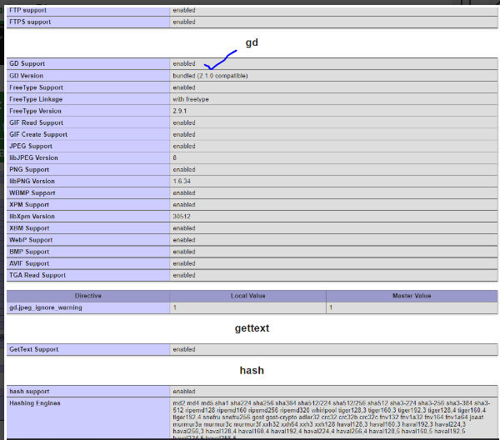

## Activity: Write PHP program for implementing different types of arrays and their associated functions. Also write program for implementing image and file handling functions.



**Output(Code with result Snapshot)**

**Arrays and its associated functions**

**Code:**

<!DOCTYPE html>

<html>

<head>

    <style>

        body {

            font-family: Arial, sans-serif;

        }

        .container {

            width: 70%;

            margin: 0 auto;

        }

        h1 {

            text-align: center;

        }

        table {

            width: 100%;

            border-collapse: collapse;

        }

        th, td {

            padding: 20px;

            text-align: left;

            border-bottom: 1px solid #ddd;

            border: 2px solid black;

            background-color:#bfe3f5 ;

        }

        th {

            background-color: #6860bd;

        }

    </style>

</head>

<body>

    <div class="container">

        <h1>Array Examples</h1>

        <?php

        // Indexed Array

        $fruits = array("Apple", "Banana", "Cherry", "strawberry");

        $moreFruits = array("Grapes", "Kiwi", "Lemon");

        // Associative Array

        $person = array("first_name" => "Keyur", "last_name" => "Patel", "age" => 20);

        // Multidimensional Array

        $employees = array(

            array("name" => "Keyur", "position" => "Manager"),

            array("name" => "Mukesh Ambani", "position" => "Businessman"),

            array("name" => "Adani", "position" => "HR")

        );

        echo "<h2>Indexed Array</h2>";

        echo "<h3>Fruits 1</h3>";

        echo "<ul>";

        foreach ($fruits as $fruit) {

            echo "<li>$fruit</li>";

        }

        echo "</ul>";

        echo "<h3>Fruits 2</h3>";

        echo "<ul>";

        foreach ($moreFruits as $fruit) {

            echo "<li>$fruit</li>";

        }

        echo "</ul>";

        echo "<h2>Associative Array</h2>";

        echo "<p>Name: " . $person["first_name"] . " " . $person["last_name"] . "</p>";

        echo "<p>Age: " . $person["age"] . "</p>";

        echo "<h2>Multidimensional Array</h2>";

        echo "<table>";

        echo "<tr><th>Name</th><th>Position</th></tr>";

        foreach ($employees as $employee) {

            echo "<tr>";

            echo "<td>" . $employee["name"] . "</td>";

            echo "<td>" . $employee["position"] . "</td>";

            echo "</tr>";

        }

        echo "</table>";

        // Using Array Functions

        echo "<h2>Array Functions</h2>";

        // Count the number of elements in the indexed array

        echo "Number of fruits: " . count($fruits) . "<br>";

        // Check if an element exists in the indexed array

        $searchFruit = "Strawberry";

        echo "Is '$searchFruit' in the fruits array? " . (in_array($searchFruit, $fruits) ? "Yes" : "No") . "<br>";

        // Combine two arrays (indexed)

        $combinedFruits = array_merge($fruits, $moreFruits);

        echo "Combined Fruits: " . implode(", ", $combinedFruits) . "<br>";

        // Sorting Indexed Array

        sort($fruits);

        echo "<h2>Sorted Fruits</h2>";

        echo "<ul>";

        foreach ($fruits as $fruit) {

            echo "<li>$fruit</li>";

        }

        echo "</ul";

        // Sorting Multidimensional Array

        function sortEmployeesByName($a, $b) {

            return $a["name"] < $b["name"] ? -1 : 1;

        }

        usort($employees, "sortEmployeesByName");

        echo "<h2>Sorted Employees by Name</h2>";

        echo "<table>";

        echo "<tr><th>Name</th><th>Position</th></tr>";

        foreach ($employees as $employee) {

            echo "<tr>";

            echo "<td>" . $employee["name"] . "</td>";

            echo "<td>" . $employee["position"] . "</td>";

            echo "</tr>";

        }

        echo "</table>";

        $slicedFruits = array_slice($fruits, 1, 2); // Get elements from index 1 to 2 (exclusive)

        echo "<h2>Sliced Fruits</h2>";

        echo "<ul>";

        foreach ($slicedFruits as $fruit) {

            echo "<li>$fruit</li>";

        }

        echo "</ul";

        // Array Reverse

        $reversedFruits = array_reverse($fruits);

        echo "<h2>Reversed Fruits 1</h2>";

        echo "<ul>";

        foreach ($reversedFruits as $fruit) {

            echo "<li>$fruit</li>";

        }

        echo "</ul";

        $reversedmoreFruits = array_reverse($moreFruits);

        echo "<h2>Reversed Fruits 2</h2>";

        echo "<ul>";

        foreach ($reversedmoreFruits as $moreFruit) {

            echo "<li>$moreFruit</li>";

        }

        echo "</ul";

        ?>

    </div>

</body>

</html>

**Output:**

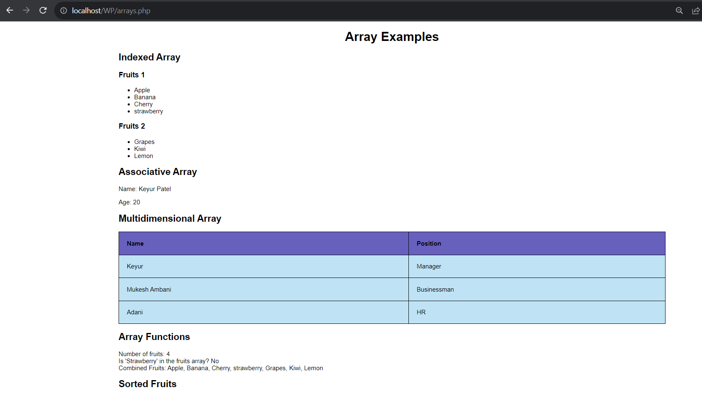

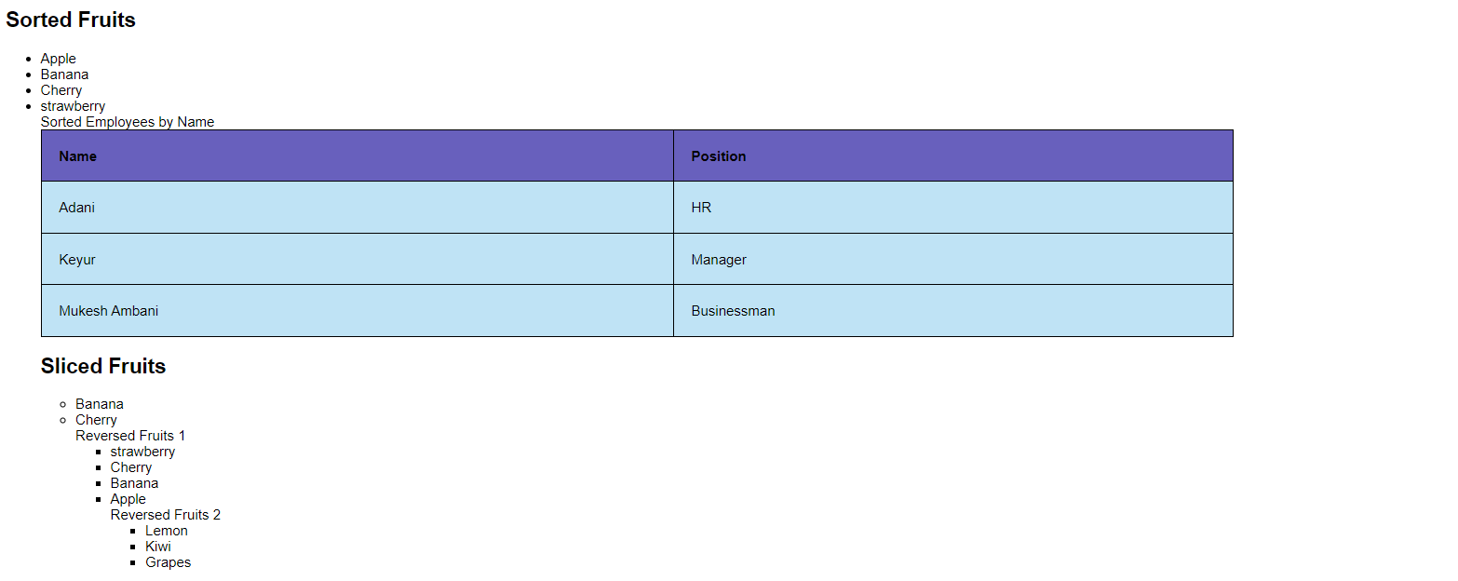

**File Handling**

**file_choose.php**

<!DOCTYPE html>

<html lang="en">

<head>

    <meta charset="UTF-8">

    <meta name="viewport" content="width=device-width, initial-scale=1.0">

    <title>File Upload</title>

    <style>

        body {

            font-family: Arial, sans-serif;

            background-color: #f4f4f4;

            text-align: center;

        }

        .container {

            background-color: #fff;

            padding: 80px;

            border-radius: 5px;

            box-shadow: 0px 0px 10px rgba(0, 0, 0, 0.2);

            width: 300px;

            margin: 0 auto;

        }

        .upload-form {

            display: flex;

            flex-direction: column;

        }

        .upload-input {

            margin-bottom: 30px;

        }

        .upload-button {

            background-color: #4CAF50;

            color: white;

            border: none;

            padding: 10px;

            border-radius: 5px;

            cursor: pointer;

        }

        .upload-button:hover {

            background-color: #45a049;

        }

    </style>

</head>

<body>

    <div class="container">

        <h2>File Upload</h2>

        <form class="upload-form" method="POST" action="upload.php" enctype="multipart/form-data">

            <input class="upload-input" type="file" name="fileToUpload" id="fileToUpload">

            <input class="upload-button" type="submit" value="Upload File">

        </form>

    </div>

</body>

</html>

**upload.php**

<?php

if ($_SERVER["REQUEST_METHOD"] == "POST" && isset($_FILES["fileToUpload"]))

{

    $targetDirectory = "uploads/";

    $targetFile = $targetDirectory . basename($_FILES["fileToUpload"]["name"]);

    if (move_uploaded_file($_FILES["fileToUpload"]["tmp_name"], $targetFile))

    {

        echo "The file " . basename($_FILES["fileToUpload"]["name"]) . " has been uploaded.";

    }

    else

    {

        echo "Sorry, there was an error uploading your file.";

    }

}

?>

**Output:**

**Before choosing file:**

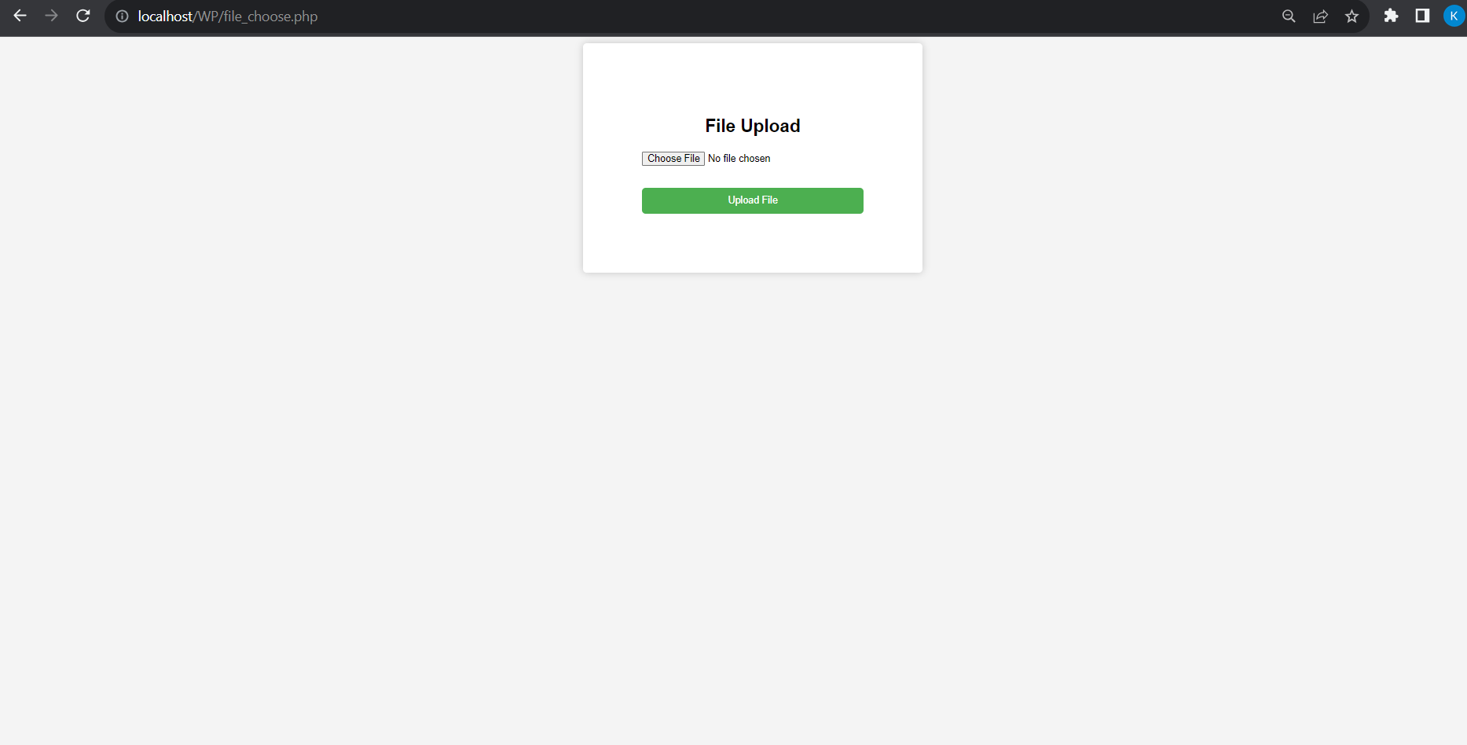

**After choosing file:**

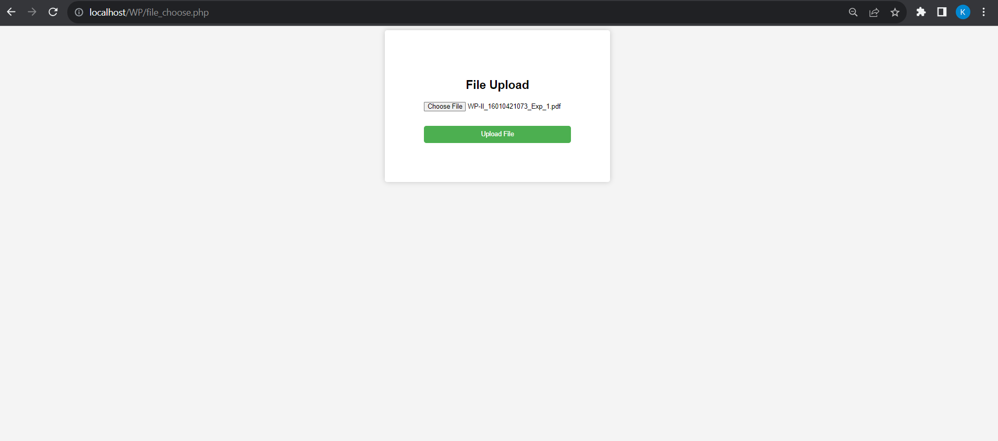

**File uploaded:**

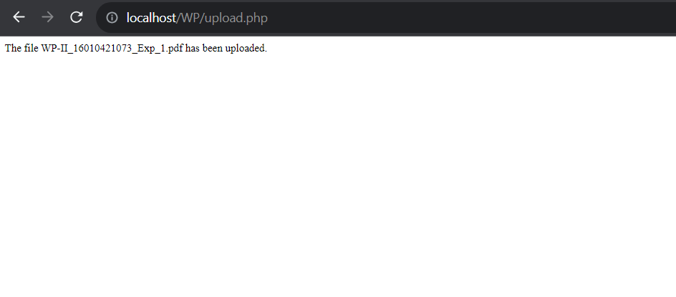

**Image Handling:**

**image_choose.php**

<!DOCTYPE html>

<html>

<head>

    <title>Image Upload and Display</title>

    <style>

        body {

            font-family: Arial, sans-serif;

            background-color: #f2f2f2;

            margin: 0;

            padding: 0;

            display: flex;

            justify-content: center;

            align-items: center;

            height: 100vh;

        }

        .container {

            background-color: #fff;

            border-radius: 5px;

            box-shadow: 0 2px 10px rgba(0, 0, 0, 0.2);

            padding: 20px;

            width: 400px;

            text-align: center;

        }

        h1 {

            margin: 0 0 20px;

        }

        form {

            margin: 0;

        }

        input[type="file"] {

            margin: 0 0 10px;

        }

        input[type="submit"] {

            display: block;

            margin: 10px auto 0;

        }

    </style>

</head>

<body>

    <div class="container">

        <h1>Upload and Display Image</h1>

        <form action="fileupload.php" method="post" enctype="multipart/form-data">

            <input type="file" name="image" id="fileToUpload">

            <input type="submit" value="Upload Image" name="submit">

        </form>

    </div>

</body>

</html>

**fileupload.php**

<!DOCTYPE html>

<html>

<head>

    <title>Uploaded Image</title>

</head>

<body>

<h1>Uploaded Image</h1>

<?php

if (isset($_POST['submit'])) {

    $targetDir = "uploads/"; // Create an "uploads" directory to store uploaded images

    $targetFile = $targetDir . basename($_FILES["image"]["name"]);

    $uploadOk = 1;

    $imageFileType = strtolower(pathinfo($targetFile, PATHINFO_EXTENSION));

    // Check if the file is an actual image

    $check = getimagesize($_FILES["image"]["tmp_name"]);

    if ($check !== false) {

        echo "File is an image - " . $check["mime"] . ".<br>";

        $uploadOk = 1;

    } else {

        echo "File is not an image.<br>";

        $uploadOk = 0;

    }

    // Check file size (you can change the size limit)

    if ($_FILES["image"]["size"] > 500000) {

        echo "Sorry, your file is too large.<br>";

        $uploadOk = 0;

    }

    // Allow certain image file formats (you can add more)

    if ($imageFileType != "jpg" && $imageFileType != "png" && $imageFileType != "jpeg" && $imageFileType != "gif") {

        echo "Sorry, only JPG, JPEG, PNG, and GIF files are allowed.<br>";

        $uploadOk = 0;

    }

    if ($uploadOk == 0) {

        echo "Sorry, your file was not uploaded.<br>";

    } else {

        if (move_uploaded_file($_FILES["image"]["tmp_name"], $targetFile)) {

            echo "The image " . htmlspecialchars(basename($_FILES["image"]["name"])) . " has been uploaded and displayed below:<br>";

            echo "<img src='" . $targetFile . "' width='300'>";

        } else {

            echo "Sorry, there was an error uploading your file.<br>";

        }

    }

}

?>

</body>

</html>

**Output:**

**Before choosing image:**

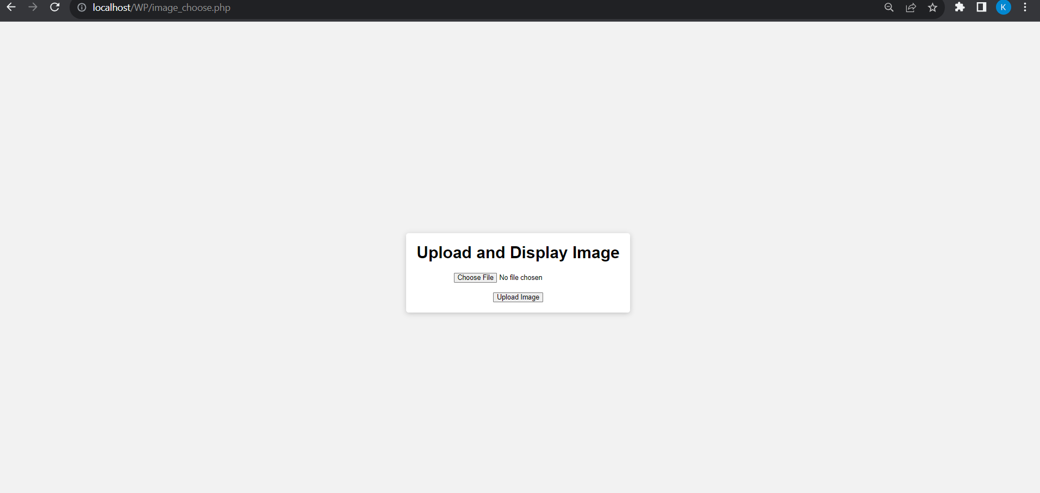

**After choosing Image:**

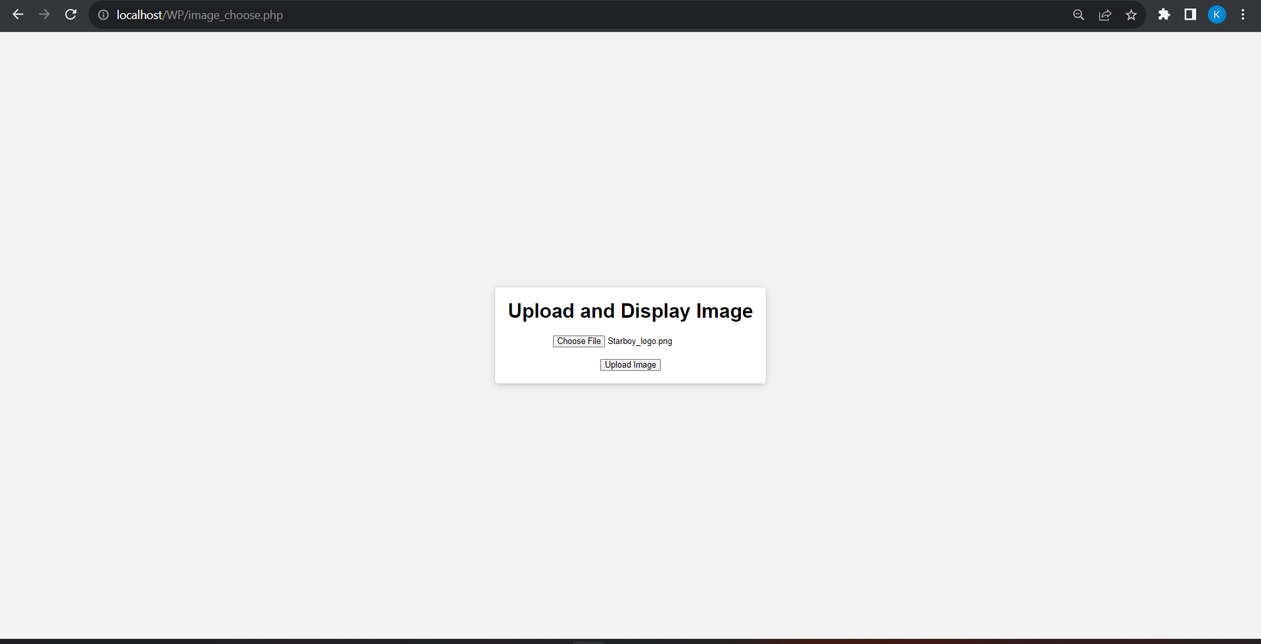

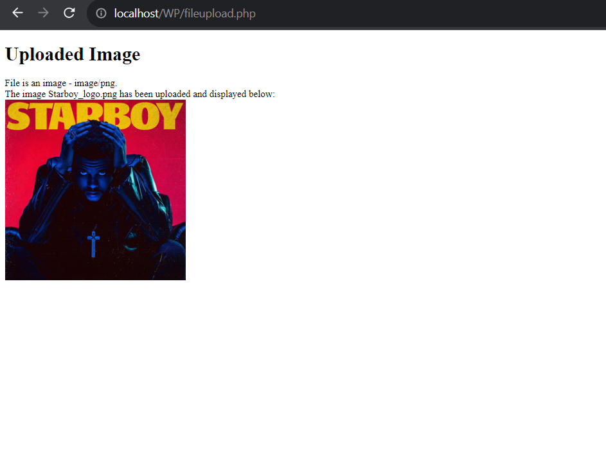

# Questions:-

# What is difference between array_merge and array_combine? Answer:

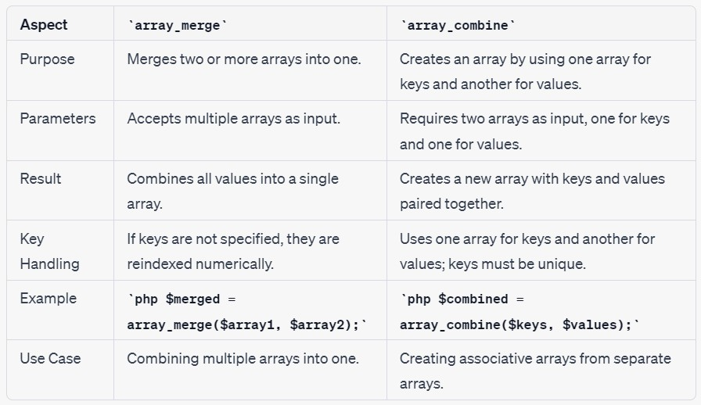

1. **Write a program based on functions passing reference as parameter. Answer:** In this program:
2. We define a function incrementByReference that takes two parameters: a reference to a number and a value by which the number should be incremented.
3. We declare the $originalNumber variable and set it to 10, and we specify the

$incrementValue as 5.

1. We call the incrementByReference function, passing $originalNumber by reference. This means any changes made to $number inside the function will affect the original variable.
2. Inside the function, we increment the value of $number by the specified increment value.
3. After the function call, we print the original number to show that it has been modified by the function.

When we run this program, we'll see that the original number is incremented by the specified value, demonstrating the use of passing variables by reference to modify them inside a function.

<?php

function incrementByReference(&$number, $value) {

$number += $value;

}

$originalNumber = 10;

$incrementValue = 5;

echo "Original Number: $originalNumber<br>";

incrementByReference($originalNumber, $incrementValue); echo "Number after increment: $originalNumber";

?>

# 3. How can you display a file download dialog box using PHP?

**Answer:** To display a file download dialog box using PHP, we can use the header function to set the necessary HTTP headers. Here's a simple example of how to do this:

<?php

// Define the file path

$file = 'path_to_your_file.pdf'; // Replace with the path to your file

// Check if the file exists if (file_exists($file)) {

// Set the appropriate headers for file download header('Content-Description: File Transfer'); header('Content-Type: application/octet-stream');

header('Content-Disposition: attachment; filename=' . basename($file)); header('Expires: 0');

header('Cache-Control: must-revalidate'); header('Pragma: public');

header('Content-Length: ' . filesize($file));

// Output the file readfile($file); exit;

} else {

// File not found

echo 'File not found.';

}

?>

In this PHP code:

1. Replace 'path_to_your_file.pdf' with the actual path to the file you want to make available for download.
2. The code first checks if the file exists using file_exists.
3. If the file exists, it sends the necessary HTTP headers to prompt the user's browser to display the file download dialog box.
4. Headers like Content-Disposition with the attachment value specify that the file should be treated as an attachment to download. The basename($file) provides the filename that will be displayed in the download dialog.
5. It sets other cache control headers to ensure the file is not cached.
6. The readfile function is used to output the file to the browser.
7. The exit function is called to prevent any further execution of the script. If the file does not exist, it will display "File not found."

When a user accesses the PHP script, the browser will display a download dialog box for the specified file, allowing the user to download it to their local machine.

# 4. What is the purpose of php.ini file?

**Answer:** The php.ini file in PHP serves as the configuration file that controls various settings and options for the PHP interpreter. It plays a crucial role in defining how PHP behaves on your web server. Here are the primary purposes of the php.ini file:

1. **Configuration Settings:** The php.ini file contains a wide range of configuration settings for PHP. These settings determine how PHP interacts with the server, handles error reporting, processes data, manages resources, and more. It allows you to customize PHP to meet the specific requirements of your applications.
2. **Error Handling:** You can specify how PHP should handle errors and log error messages. This includes options for displaying errors on the screen, writing errors to log files, and configuring error reporting levels.
3. **Security:** PHP configuration settings in php.ini can be used to enhance the security of your PHP applications. You can enable or disable features that may pose security risks, set permissions, and control access to certain functions.
4. **Resource Management:** You can configure resource limits, such as memory limits, execution time limits, and file upload limits. This helps in preventing excessive resource consumption or long-running scripts that could impact server performance.
5. **Extension Configuration:** PHP extensions (e.g., MySQL, GD, cURL) are often controlled through php.ini. You can enable or disable specific extensions and set their configuration options.
6. **Output Buffering:** PHP offers output buffering, and you can configure its behavior in php.ini. This can be useful for improving performance and managing the content sent to the browser.

**Outcomes: CO1:** Illustrate use of basic PHP concepts to develop applications.

**Conclusion: (Conclusion to be based on the objectives and outcomes achieved)** Understood how to create Indexed, Associative, Multi dimensional arrays in PHP and use the different array functions linked with them.

Learned how to use built-in PHP functions and how to define our own functions with or without parameters and returning value if needed.

Also learned to implement the file and image handling functions in php.

# Grade: AA / AB / BB / BC / CC / CD /DD

**Signature of faculty in-charge with date References:**

**1.** Instruction Link to install php GD –

<https://www.geeksforgeeks.org/how-to-install-php-gd-in-windows/>

# Books:

1. Thomson PHP and MySQL Web Development Addison-Wesley Professional , 5th Edition 2016.



1. Peter MacIntyre, Kevin Tatroe Programming PHP O'Reilly Media, Inc, 4th Edition 2020
2. Frank M. Kromann Beginning PHP and MySQL: From Novice to Professional, Apress 1st Edition, 2018